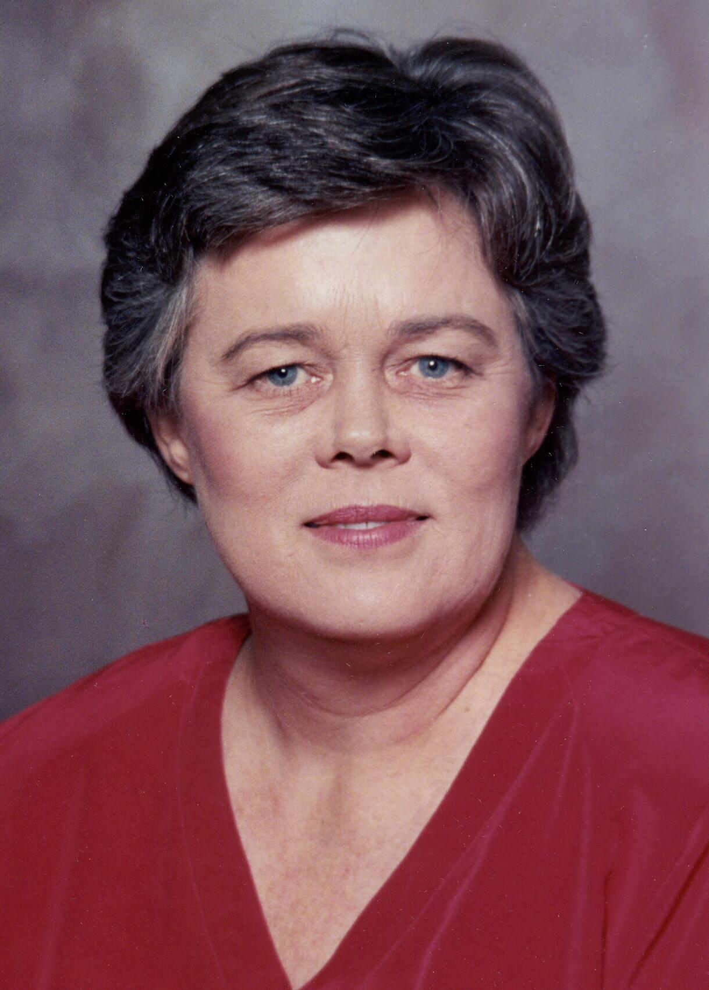
Sally Ann Moon

I was born in Peralta Hospital in Oakland California on Friday July 12, 1946. The time was about noon, so Mom missed lunch. I joined the family as the second child of Robert Steeg (aka Bob) and Mary Willette (aka Billie) Moon. The couple’s first child was my brother Bob Jr. born two years earlier on June 2, 1944. As it turns out, I missed being born on my Dad’s birthday by 6 days. He was born on July 6.

I was a darn cute baby but not a perfect child. I was born with an anomaly that was the equivalent of an extra muscle tied around the opening of my stomach. The milk Mom fed me only dripped into my stomach because the opening was so small. I was underweight and undernourished. It took almost a whole year for the doctor’s to figure out why I could not consume sufficient food to grow normally. They finally determined what the problem was and that the only solution was to put a very small set of pincers on a rubber tube down my throat to stretch that muscle out. The first time they performed this procedure; I was too weak to be given any anesthetic. Mom said I screamed the entire time they were working on me. Can you imagine? A one-year-old child having a rubber tube shoved down her throat and then a muscle stretched out? Mom could not get me near a doctor with a white coat on for four or five years. They performed this procedure three more times by the time I was five years old, but after that first time I had gained weight and was healthier so they could give me anesthesia. All the time I was growing up, I was aware that I had to be careful to chew up my food so it would not get stuck in my throat. When I as not careful, Mom taught me how to drink enough water to force the food down or make it come back up. Not fun. To this day, occasionally I will have to work to get food down, but I can feel it beginning to happen before it becomes a problem. Even so, twice in my life I have had to have a doctor go in and remove some food that got stuck to a point where water would not move it.

Because of this problem, Mom was very protective of me and kept me close to home. As a result I was pretty shy and afraid to be very far away from Mom.

In 1947 the family moved out to Walnut Creek, California. We lived on Ivy Court, just a few blocks from the center of Walnut Creek, along with five other families. There were ten children of various ages similar to our family so I made a few friends. And once I started to go to school I met more kids and had more friends to play with so my shyness slowly went away. I remember one very close friend, Suzanne. Her dad owned the Foster Freeze down on Mt. Diablo Blvd. in Walnut Creek. We were allowed to ride our bikes down the hill to get an ice cream cone when it was hot in the summer.

Through the back yard gate was the first Walnut Creek Elementary School. As children we often played on the school grounds. But I did not go to classes there until the fourth grade. Walnut Creek bused children around town to fill up all the classrooms in the various schools around town.

My shyness rose up again on my first day of kindergarten. I cried when Mom left me in the classroom. I was scared to death to think that she would leave me with all those strangers. Thankfully I soon got over being scared and made friends.

I attended Parkmead Elementary school for kindergarten, Buena Vista for first and second grade, Walnut Creek Elementary for third grade and the start of fourth.

Early in the school year of fourth grade in 1955, Dad and Mom bought a new house on Ygnacio Valley Road in a new area of Walnut Creek. It was finished and we moved in on November 15th 1955. This house was a very modern Eichler house with a flat roof, walls of windows, interiors of Philippine mahogany and radiant heat in the floor. It had four bedrooms and two bathrooms, a living room, dining room, kitchen and large back yard. I loved that house. That first winter we lived there, I remember it rained a lot and because of the construction debris clogging the drains, the streets flooded half way up the driveway. Mom had to walk out to get to work.

After we moved I went to Ygnacio Valley Elementary for the rest of fourth grade. Then they built a new school near our home, Walnut Acres and I attended 5th and 6th at this school before moving on to intermediate school. Again a new school was built but it was not completed until about December of my 7th grade. That was Oak Grove Intermediate. For High School, I went to Clayton Valley High School for the first and second year then Ygnacio Valley Hi was built and the last two years were spent at this school. We were the first graduating class, we got to pick the school colors, the mascot, one of my senior classmates wrote the school alma mater and the kids in the wood working classes made the letters for the Gym spelling out our teams name of the Warriors. I was a cheer leader that first yhear which was my junior year. I was among the first graduating class of the new school and I learned that I had a voice that carried well. For the first time in my life I felt like I was a part of the in-crowd. I was still shy but as I grew up I overcame that. With the exception on the Walnut Creek Elementary all of these schools are still providing education to the children of Walnut Creek and Concord sixty some years later.

After graduating high school in 1964 I went to Chico State college and lived in the dorms. Mom and Dad drove me up there (it is a three hour drive from Walnut Creek to Chico) and helped me move in. When they left it felt like my first day at kindergarten all over. I was left alone to fend for myself and I cried for a couple of minutes. Then I got to know my roommate and learned about the school and found friends quickly. The fear did not last long. That first semester I started smoking (following in the footsteps of my parents) and I had to change roommates at the end of the first semester because my roommate did not like smoking. My major that year was biology and I got fairly good grades (that means B’s).

I had been dating Loren King since my junior year at high school. He joined the Air Force and we called and stayed in touch as I went off to college. In December 1964 we decided to get married ahead of our wedding scheduled for June 1965 so I would get a monthly check as the spouse of a service man. We told our parents we were going to play in the snow but went to Reno to elope. We got back very late after 1:00 am from that trip and my dad was very angry. My parents had been scared something had happened to us when we did not get back by 10:00 as we said we would. As angry as he was Dad restrained himself from telling Loren he could never see me again. This was the biggest secret I had ever kept. I never did tell my parents. Bob’s best friend from high school, Bud Beemer, found the announcement of the marriage license in the Reno paper and sent it to me. He agreed to keep the secret for me.

We announced our engagement at home right after Christmas and again at the dorm when the spring semester started up in January. In the Dorms they made a big deal over engagements with a candlelight ceremony flowers and pictures posted on the bulletin board. After all that was what we girls were supposed to aspire to.

In June after my freshman year of college, Loren and I got married in a church wedding at St Paul’s Episcopal church in Walnut Creek. The reception was held in our backyard. All of our family and friends were there. Mom made my dress and the dresses of the brides maids. She also made the suit I wore when we left for the honeymoon. I got Loren a super eight movie camera as a wedding present and someone took movies of the reception. Our honeymoon was spent in San Francisco and we visited the Zoo the first day and then down on the peninsula for a couple of more nights. But by the fourth day I was so exhausted I told Loren to take me home. Mom took one look at me and sent me to bed for a nap. I slept for at least four hours and woke up refreshed and ready to drive to Riverside where Loren was stationed in the Air Force. He had rented a fairly small one-bedroom, one-bath apartment off base. There was a wringer washer and a clothes line for all four tenants to use. Boy did that bring back memories of Ivy Court. We became very good friends with his buddies from the base and their wives.

My education was put on hold until after Loren got out of the military and graduated from college where he qualified for a teaching credential. Mom passed away in December 1972 as we were moving to Salinas in Monterey County. I attended the local Junior College during my marriage but did not get very far since I could only take one class a semester while working full time and taking care of our home. Loren and I bought a home and put in the front yard and played tennis. After eleven years of marriage Loren and I had grown in different directions and finally divorced. I started working towards getting my degree with more earnest. I moved home with Dad and I finally graduated from the University of San Francisco with a Bachelor of Science degree in Human Relations and Organizational Behavior (a fancy name for a business degree).

I started my employment career with J.C. Penney Company in the Women’s Lingerie Department in Riverside California when I was first married and Loren was stationed at March Air Force Base. It did not take long standing on my feet for eight hours a day to know that retail was not gong to be my final career choice. The next job I got was with Pacific Telephone & Telegraph as an Information Operator. After about four or five years I moved into the Long Distance section. This was before direct dial was available and my job was to connect people with each other from one town to another using a cord board similar to the one used by Lily Tomlin in her portrayal of Ernestine in her comedy pieces. I later graduated into the Customer Service department taking orders for residential telephone service and later taking orders for the large businesses and large homes of the movie stars that lived on the Monterey Peninsula in California. That career lasted until I took a leave of absence to go back to college to finish my degree in 1977. With perseverance after nineteen years I actually graduated from college.

After college I was employed for almost twenty years in the mortgage and banking industry. Much later in life I switched to Homeowner Association management.
I spent ten years as a Director on the Board of the Homeowner’s Association where I own a home. This was a special opportunity to work with others in the management of a million dollar corporation. I learned a lot about politics, listening to the ideas of others and overseeing the budget and financial status.

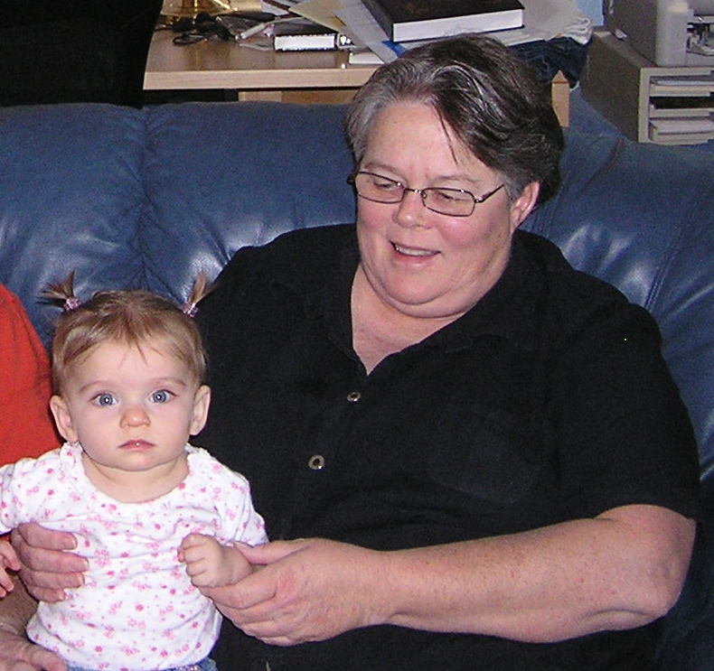
My favorite things to do are reading all kinds of books, including fiction and non-fiction. My favorite authors are Barbara Taylor Bradford, Patricia Cromwell, and Bob Woodward, I love the cooking shows on KQED public television on the Food Network. Another favorite in TV viewing is the Hallmark channel and Hallmark Movies & Mysteries. For many years I made all my own clothes and I am now interested in learning to quilt and use the sophisticated sewing machine that I purchased a few years back. When I was younger I played tennis, loved to dance and was quite active in outdoor entertainment. At age 71 I need to get back into shape and loose weight.

The picture above was taken at thanksgiving 2006. That is Maryam Moon, Toby’s daughter I am holding. She is about eight months old and as cute as a bug in a rug.
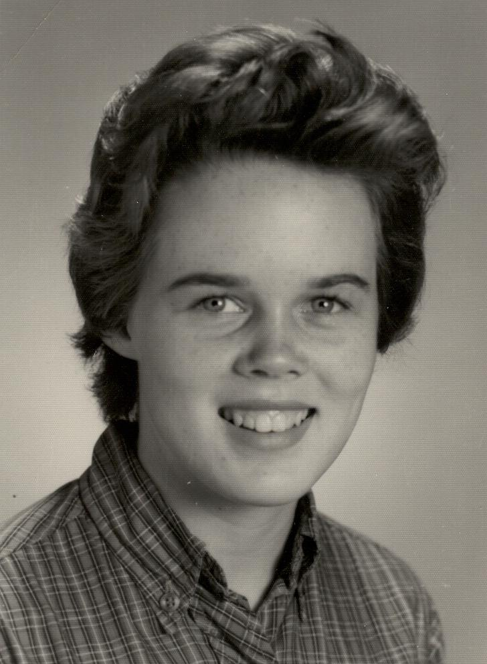
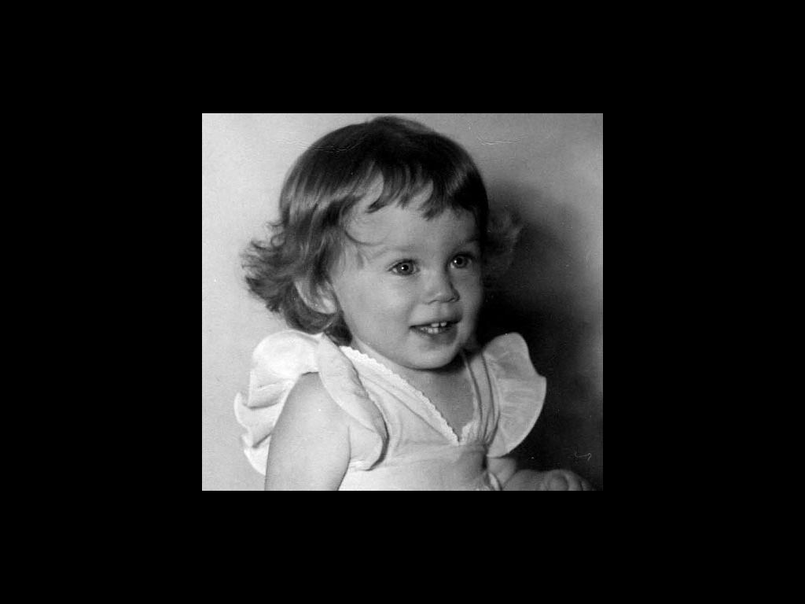

Picture directly above was taken in 1947 when I was one year old.

The picture to the right was taken my freshman year of high school for the year book. It was taken in 1960 and attached to a Christmas card sent to Pop Moon, (William 1888). The inscription on the back of the picture says; ”To Pop, I hope you have a very merry Christmas 1960. With all my Love, Sally Moon”

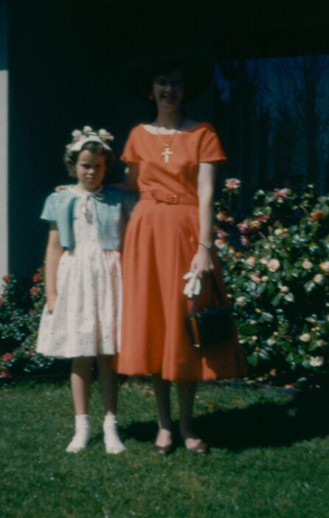
The picture to the left was taken about 1954 in the backyard at our home on Ivy Ct. in Walnut Creek. I was about eight years old. Mom and I are dressed up in our Easter Best. Mom made my dress and jacket but I don’t remember if she made her dress as well. I am not sure why my unhappy face but it looks pretty sour.
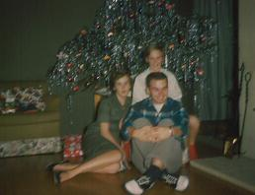

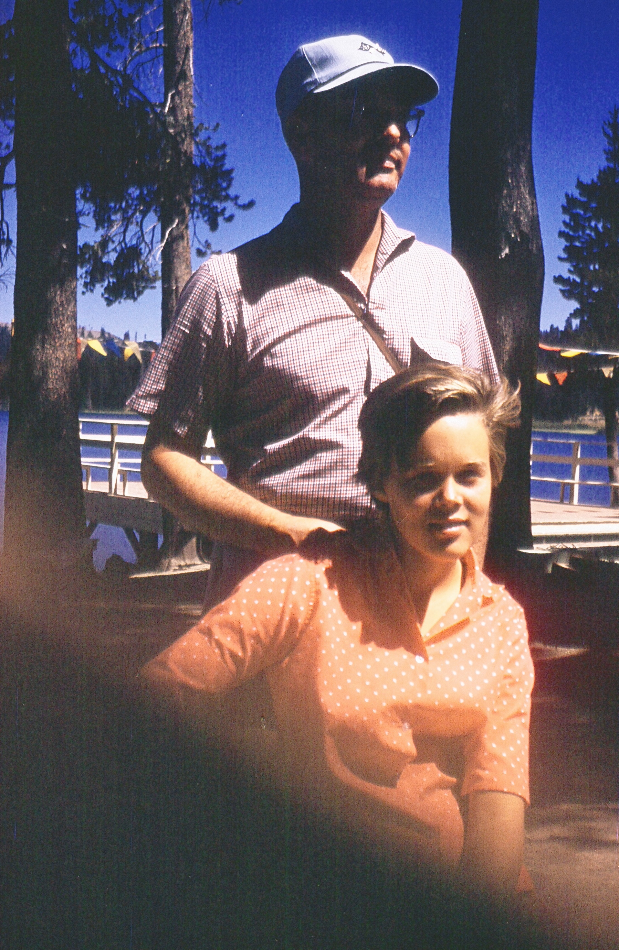
The three Moon kids; this picture was taken at Christmas circa 1958. Sally is on the left, Bob on the right and Mary is in the back behind Bob.

The picture to the left was taken at the Sierra Lakes Club in about 1957 and that is Dad and me. This club was west of and down the moun tain from Donner Lake in the Sierra Nevada Mountains. We went there for about two or three years for our family summer vacations. It was fun to canoe on the lake or ride horses around the lake, (it was a small lake). We went with our neighbors from Ivy Court where the adults played bridge.

After spending 13 years in the telephone service industry, 3 years in the insurance industry and 16 years in the mortgage industry I moved to Homeowner Association Management. I was very successful at this occupation. I was able help Associations with construction projects to maintain the buildings of the commnity such as reroof all buildings, replace rotten siding, rebuild car ports, replaster swimming pools etc. I enjoyed the work and the communication with the homeowners and the Board Members. The only negative for this job was the long hours necessary due to attending Board meetings at night after working all day.

I was able to retire in December 2013 at the age of 67. What I see next in my life is to work at learning quilting, getting fit through exercise.

